WRITING IN BINARY

Convert the following numbers to binary using the charts

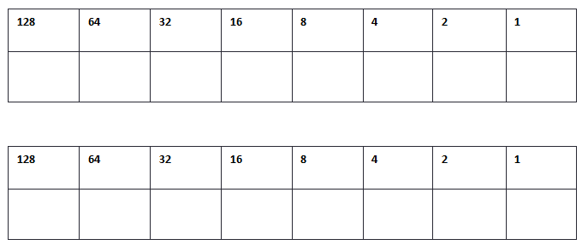
32
34
43
122

Now try writing the binary without the charts

56
____________________________

38
____________________________

121
____________________________

9
____________________________

18
____________________________

Convert the following binary numbers into denary:
- 0 0 1 1 0 0 1 1
- 0 1 1 1 1 1 1 1
- 1 0 0 1 1 0 0 1
- 0 1 1 1 0 1 0 0
- 1 1 1 1 1 1 1 1
- 0 0 0 0 1 1 1 1
- 1 0 0 0 1 1 1 1
- 1 0 1 1 0 0 1 1
- 0 1 1 1 0 0 0 0
- 1 1 1 0 1 1 1 0
- 0 0 0 1 1 1 1 0 0 1 1 1
- 0 1 0 1 0 1 0 1 0 1 0 0
- 1 1 1 1 0 0 0 0 1 1 1 1
- 0 1 1 1 1 1 0 0 1 0 0 0
- 0 1 1 1 1 1 1 1 1 1 1 1
- 0 1 1 1 1 1 0 0 1 1 1 1 0 0 0 0
- 0 0 1 1 1 1 1 1 0 0 0 0 1 1 0 1
- 1 1 0 0 0 0 1 1 0 0 1 1 1 1 1 1
- 1 0 0 0 1 0 0 0 1 0 0 0 1 0 0 0

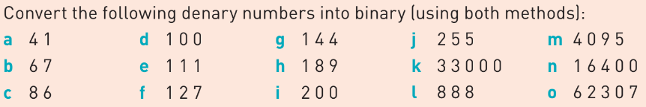
Method 1:
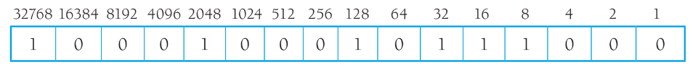
Method 2:
